Name___________________________
Date ________________
Period _________

EARTH SCIENCE REGENTS

Factors Controlling Climate

Copyright 2020 by Z. Miller
Companion Website: https://www.bloomberg.com/graphics/2015-whats-warming-the-world/

Climate is the long-term average of weather, typically averaged over a period of 30 years¹. It is difficult for us to grasp a variation in climate due to this large timescale. We can grasp variations in weather – short-term changes in the atmosphere. For example, a humid day, a frigid week, or even a particularly warm or wet summer are all relatively small intervals of time that feel relevant and memorable. Therefore, climate, the average of decades worth of data, is best analyzed using large timescale graph. Specifically, climate factor graphs attempt isolate individual climate variables – you will study this scientific practice in this activity.

A “climate forcing” is a factor, or variable, that influences, or controls, climate. Climate forcings can include:
- orbital changes – the tilt of earth’s axis, or the shape its orbit.
- solar activity – the intensity of radiation being emitted by the sun.
- volcanic dust – small sediments, or bits of rocks, that enter the stratosphere.
- land use – changes in the quantity and quality of carbon sinks (deforestation).
- Ozone – a pollutant and also a greenhouse gas.
- Aerosols – tiny suspended particles that can include sulfates, black carbon, smog, and other material.
- greenhouse gases – carbon dioxide, methane, and others gases.

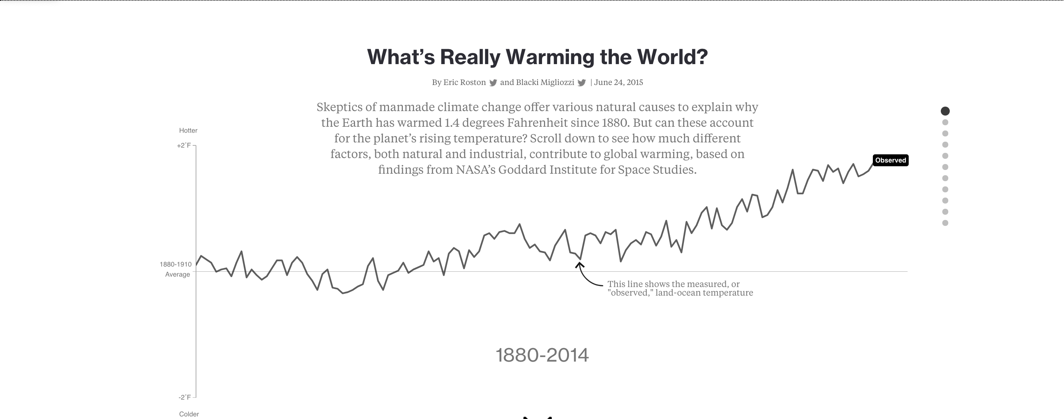

1) Are the short-term increases and decreases significant in the above graph? Why or why not?
_________________________________________________________________________________________
_________________________________________________________________________________________
2) Draw, with a colored pencil, a “best fit” or “trend line” of the above temperature dataset.

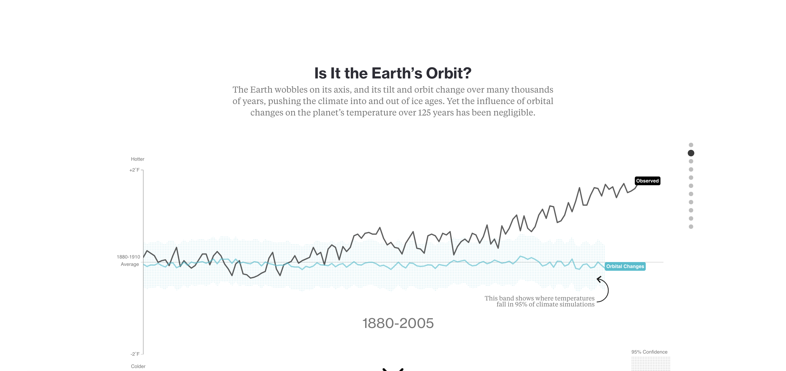
You can circle terms, or write the terms, for the blanks below.
3a) What is the climate forcing (cause that affects temperature) shown above? _________________________
3b) The climate forcing above is generally _______________ (increasing, decreasing, or remaining the same) global temperature for the entire period of time shown on the graph.
3c) The climate forcing above is ______________________ (human caused, or naturally occurring).
3d) A climate question you can come up with for the above climate forcing is:
_________________________________________________________________________________________
_________________________________________________________________________________________
Draw a model summarizing the climate forcing above:

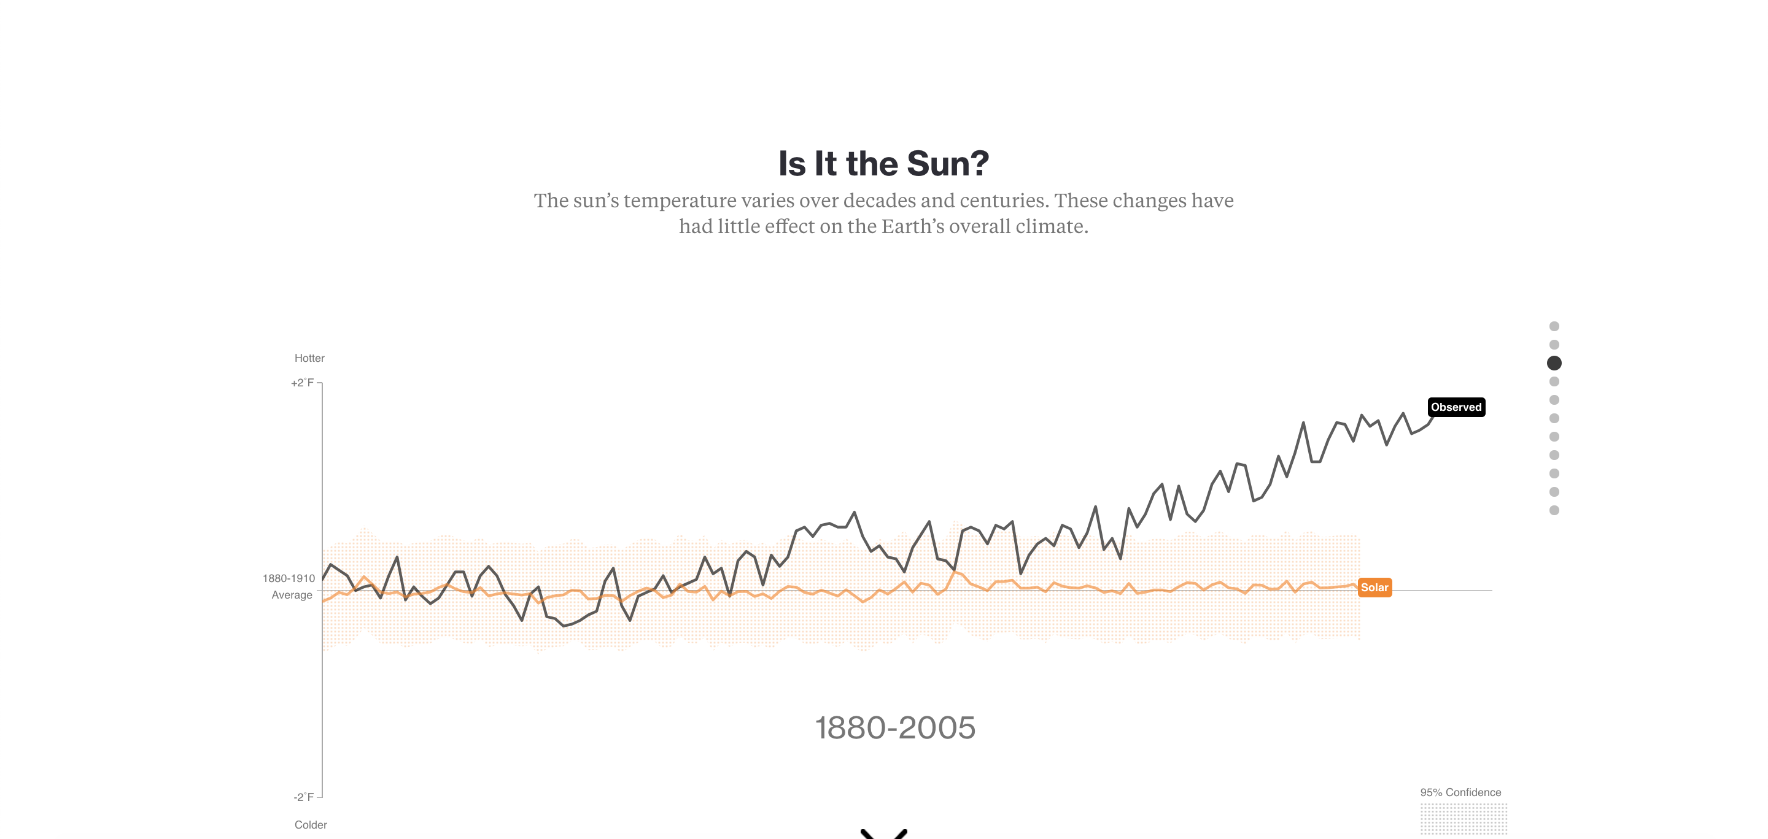
4a) What is the climate forcing (cause that affects temperature) shown above? _________________________
4b) The climate forcing above is generally ________________ (increasing, decreasing, or remaining the same) global temperature for the entire period of time shown on the graph.
4c) The climate forcing above is ______________________ (human caused, or naturally occurring).
4d) A climate question you can come up with for the above climate forcing is:
_________________________________________________________________________________________
_________________________________________________________________________________________
Draw a model summarizing the climate forcing above:

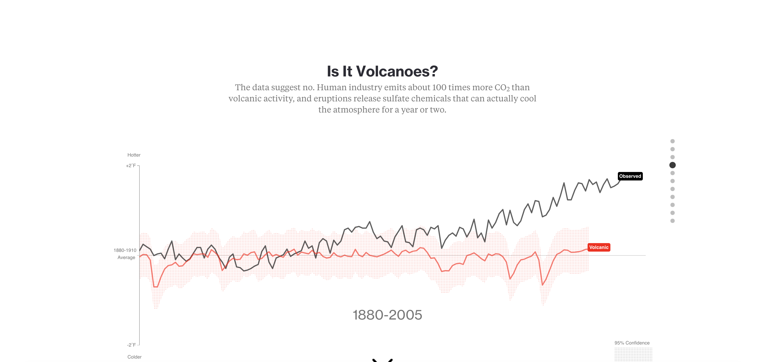
5a) What is the climate forcing (cause that affects temperature) shown above? _________________________
5b) The climate forcing above is generally ________________ (increasing, decreasing, or remaining the same) global temperature for the entire period of time shown on the graph.
5c) The climate forcing above is ______________________ (human caused, or naturally occurring).
5d) A climate question you can come up with for the above climate forcing is:
_________________________________________________________________________________________
_________________________________________________________________________________________
Draw a model summarizing the climate forcing above:

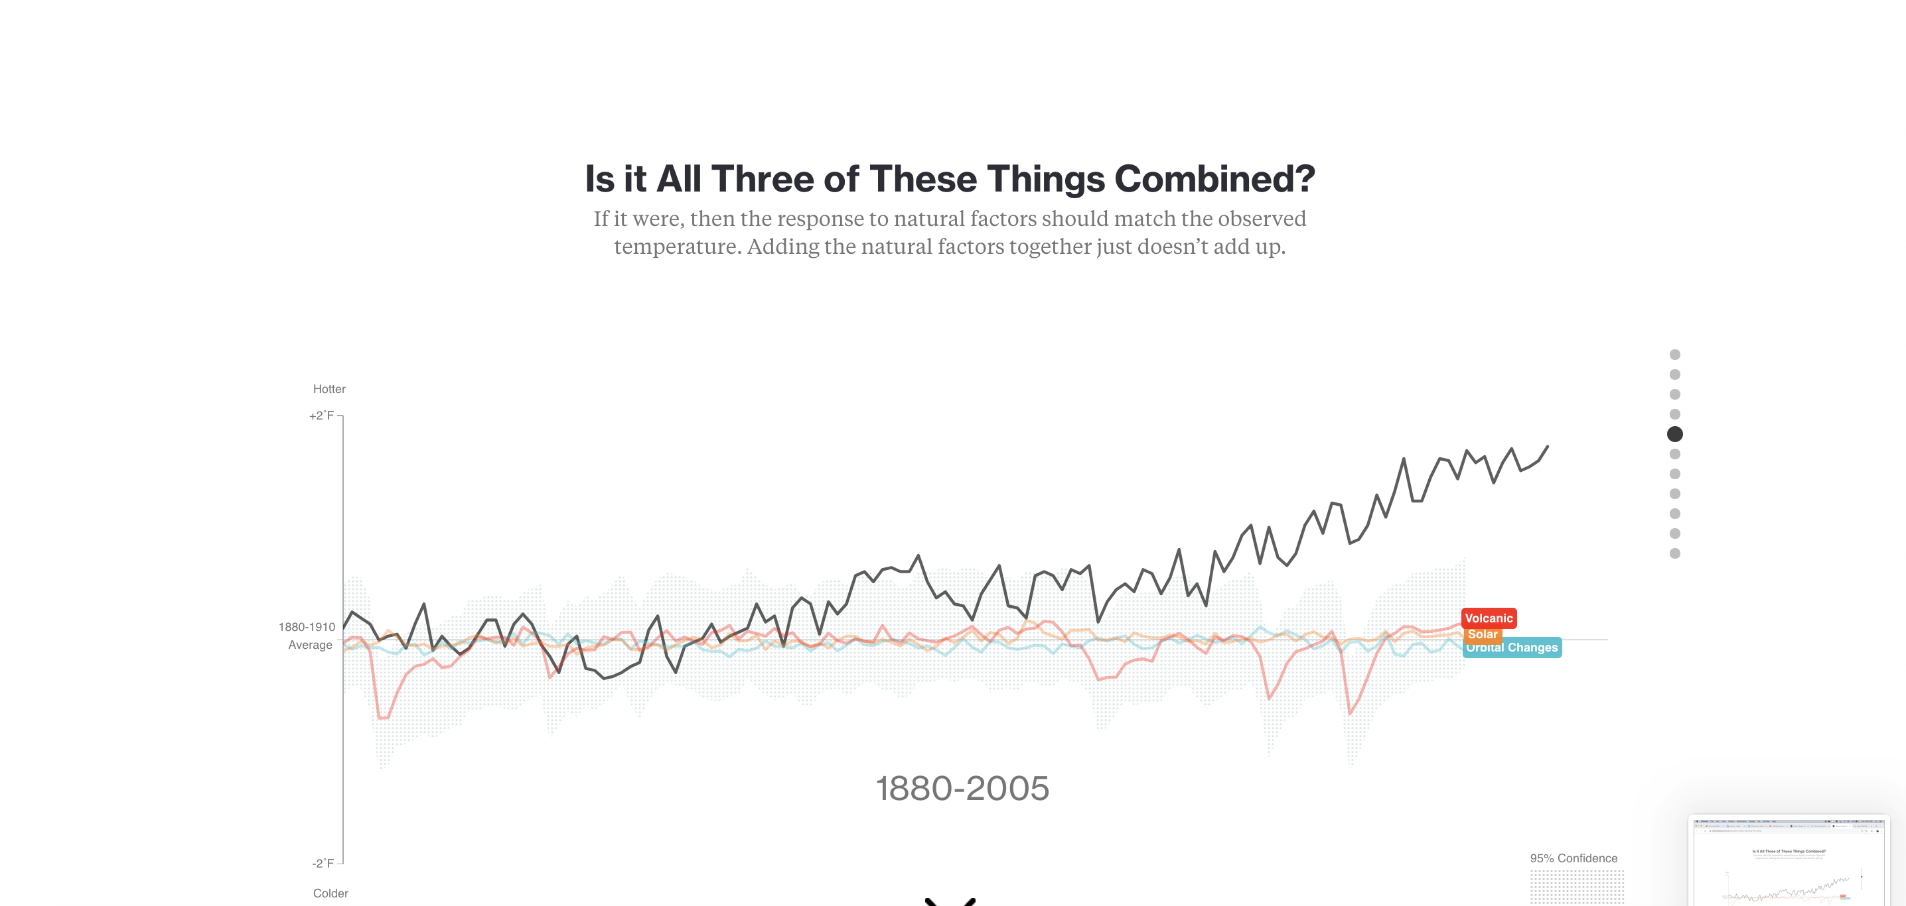
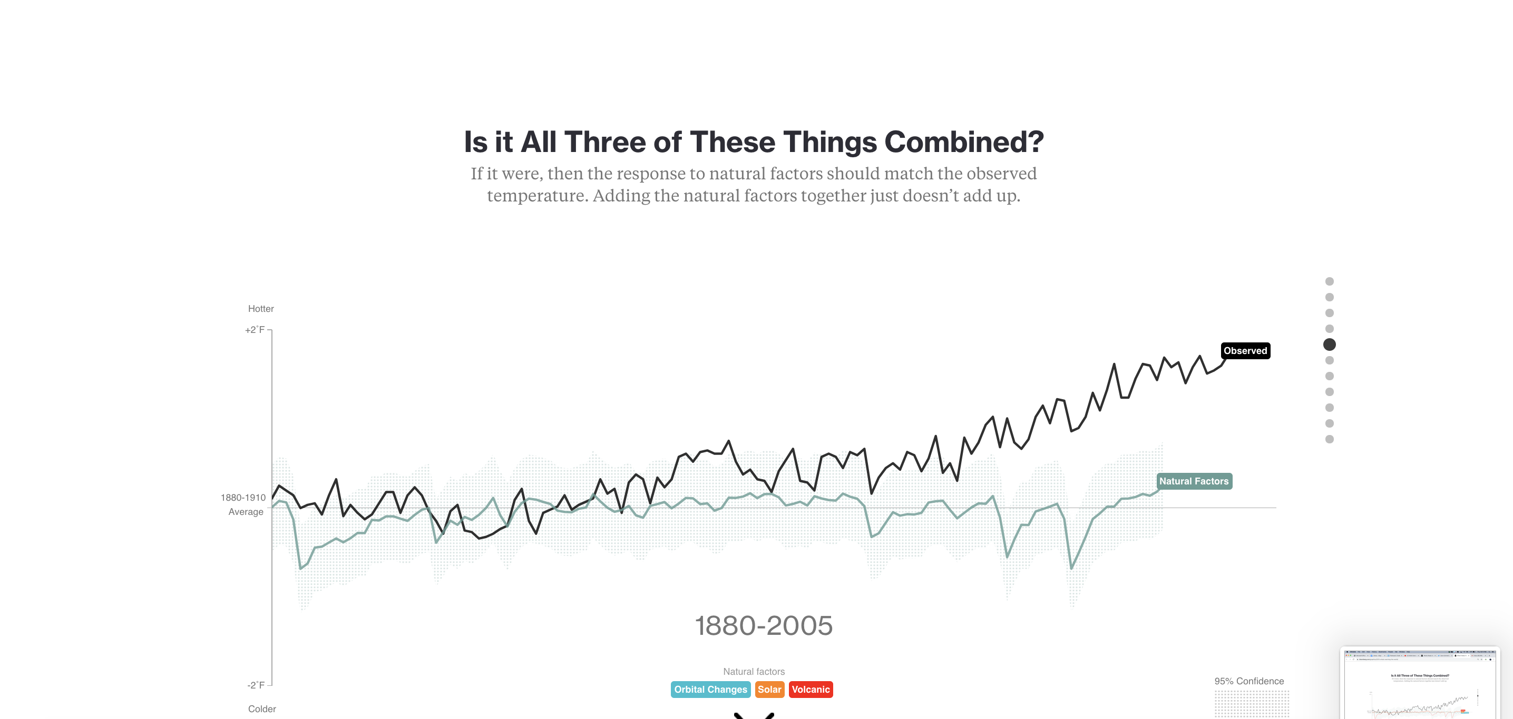
6a) What do all three forcings – orbital changes, solar variability, and volcanic eruptions all have in common?
_________________________________________________________________________________________
6b) Why might the instrumental temperature record (the black line) not correspond, or matchup, with the “natural factors” (green line on lower graph above)?
_________________________________________________________________________________________
_________________________________________________________________________________________

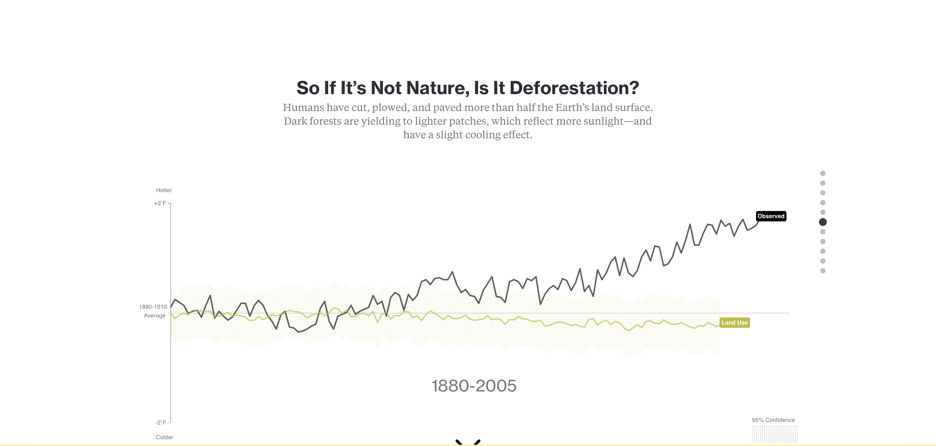
7a) What is the climate forcing (cause that affects temperature) shown above? _________________________
7b) The climate forcing above is generally ________________ (increasing, decreasing, or remaining the same) global temperature for the entire period of time shown on the graph.
7c) The climate forcing above is ______________________ (human caused, or naturally occurring).
7d) A climate question you can come up with for the above climate forcing is:
_________________________________________________________________________________________
_________________________________________________________________________________________
Draw a model summarizing the climate forcing above:

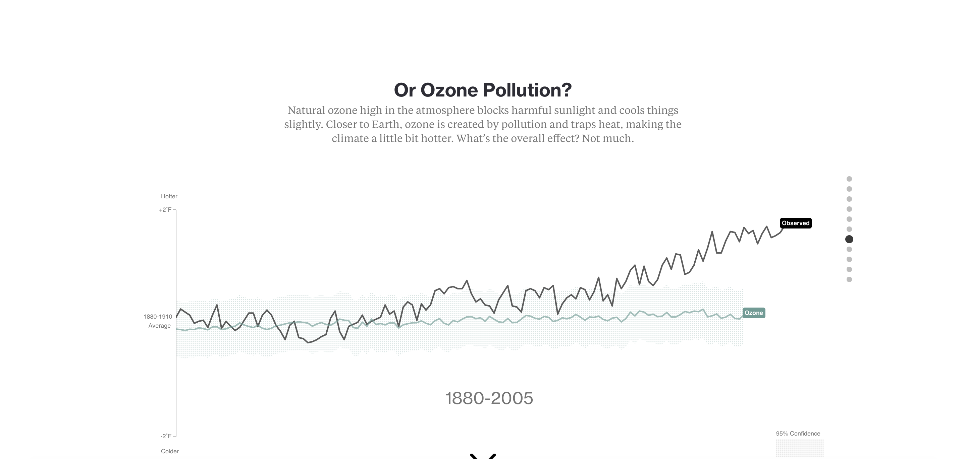
9a) What is the climate forcing (cause that affects temperature) shown above? _________________________
9b) The climate forcing above is generally ________________ (increasing, decreasing, or remaining the same) global temperature for the entire period of time shown on the graph.
9c) The climate forcing above is ______________________ (human caused, or naturally occurring).
9d) A climate question you can come up with for the above climate forcing is:
_________________________________________________________________________________________
_________________________________________________________________________________________
Draw a model summarizing the climate forcing above:

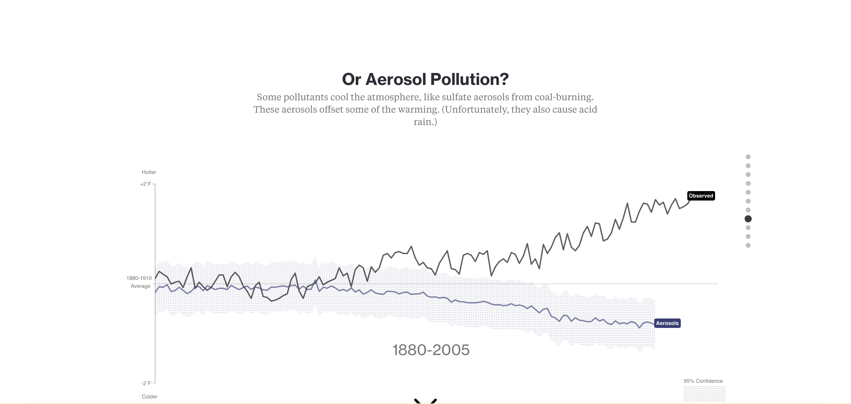
10a) What is the climate forcing (cause that affects temperature) shown above? ________________________
10b) The climate forcing above is generally _______________ (increasing, decreasing, or remaining the same) global temperature for the entire period of time shown on the graph.
10c) The climate forcing above is ______________________ (human caused, or naturally occurring).
10d) A climate question you can come up with for the above climate forcing is:
_________________________________________________________________________________________
_________________________________________________________________________________________
Draw a model summarizing the climate forcing above:

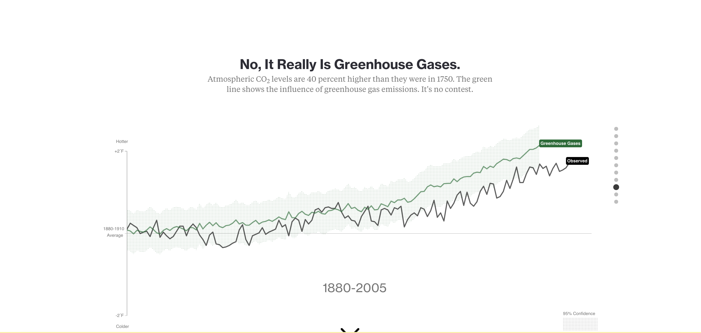
11a) What is the climate forcing (cause that affects temperature) shown above? ________________________
11b) The climate forcing above is generally _______________ (increasing, decreasing, or remaining the same) global temperature for the entire period of time shown on the graph.
11c) The climate forcing above is ______________________ (human caused, or naturally occurring).
11d) A climate question you can come up with for the above climate forcing is:
_________________________________________________________________________________________
_________________________________________________________________________________________
Draw a model summarizing the climate forcing above:

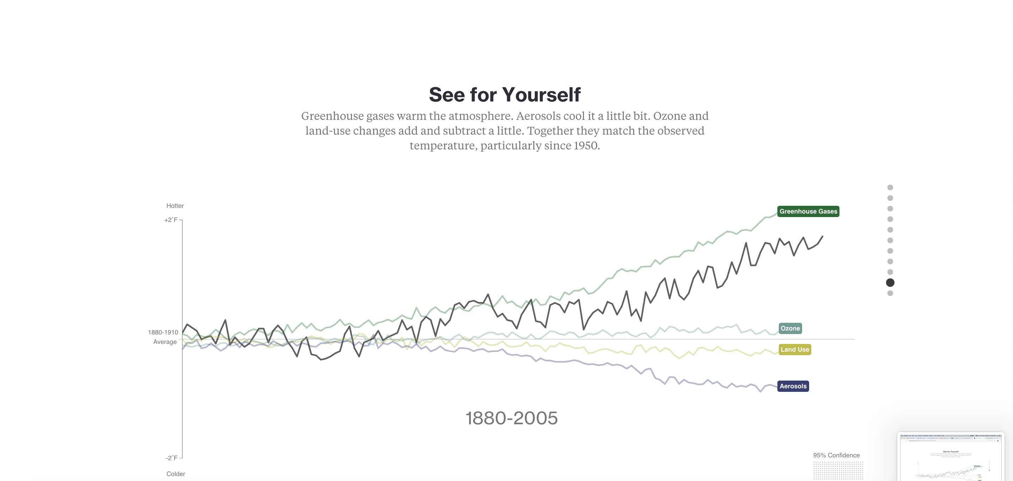
12) How do greenhouse gases compare to ozone, land use changes, and aerosols in terms of climate forcing?
_________________________________________________________________________________________
_________________________________________________________________________________________
_________________________________________________________________________________________
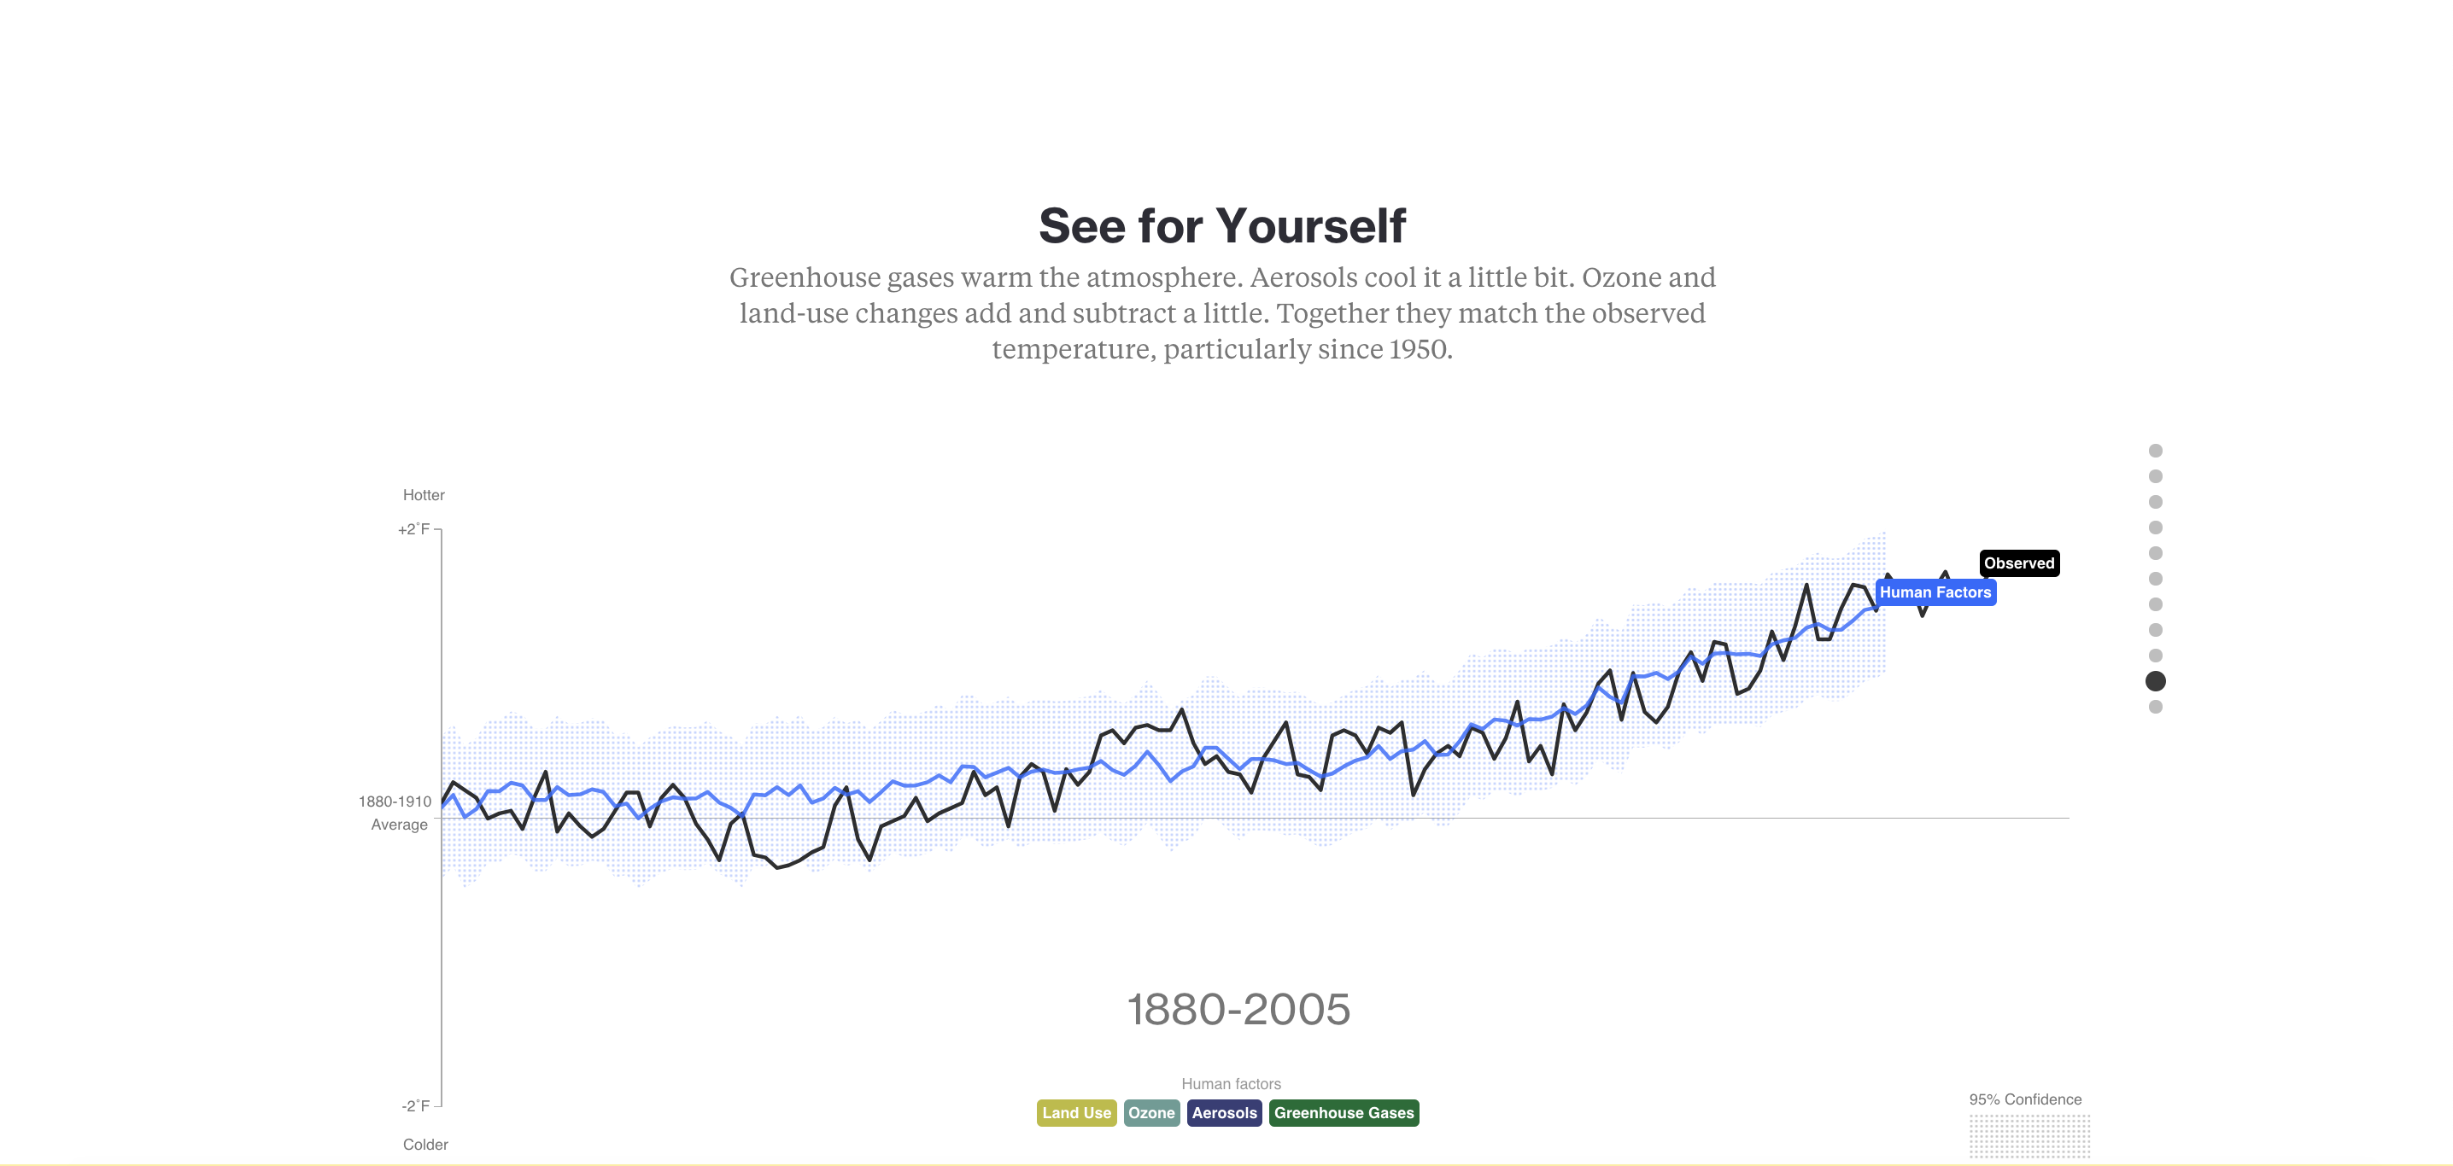
13) What does the blue line above represent?
_________________________________________________________________________________________
_________________________________________________________________________________________
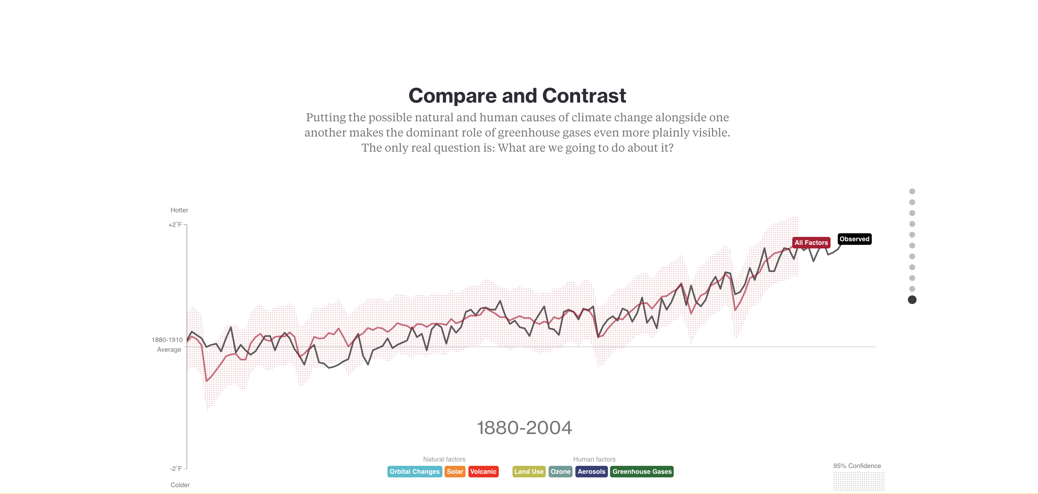
14) Overall, or “on the net”, do the climate forcings, or climate factors, match the observed temperature record? Why or why not?
_________________________________________________________________________________________
_________________________________________________________________________________________
Conclusion
Write a brief summary as to what you gained from this activity:
_________________________________________________________________________________________
_________________________________________________________________________________________
_________________________________________________________________________________________
_________________________________________________________________________________________
_________________________________________________________________________________________
_________________________________________________________________________________________

References:
- Planton, Serge (France; editor) (2013). "Annex III. Glossary: IPCC – Intergovernmental Panel on Climate Change" (PDF). IPCC Fifth Assessment Report. p. 1450. Archived from the original (PDF) on 2016-05-24. Retrieved 25 July 2016.

