Review and Reinforcement on Rotation/Revolution/Time Differences
Directions: Complete the sentences below based on your understanding of earth’s motions.
Earth is _____________ around the Sun all the time – a complete cycle of this motion takes one “year”. Meanwhile, earth is constantly ________________ on its _____________to create what we call “day and night”. Let’s look first at Rotation.
It is the motion of rotation which causes the sun to appear to __________ and __________ each day. In fact, ALL celestial objects (objects seen by ANY earthbound observer) rise and set each day as a result of earth’s motion termed _______________. Using ESRT’s p. 15 to look up some information: Earth takes ______ hours (ROUND TO THE NEAREST HOUR!) to complete one full rotation. If the earth is a sphere made up of 360°, calculate now the rate of the earth’s rotation in degrees per hour (°/hour) (be thorough with your math…meaning include units!).
Work Space: Final Answer:
Therefore, ALL celestial objects appear to move across the sky at an approximate rate of _________ degrees per hour (you have to know this rate…but I’d rather you understand how we derived it!). Our local time – the time our watch or a clock reads – is based therefore on this apparent movement of 360°/day of our nearby star – the ______ ! Since the sun moves across the earth’s surface roughly parallel to lines of ___________________ (pick one: longitude / latitude), it makes sense that time zones on earth are separated by roughly ____________ degrees of __________________ .
Again, because the apparent motion of the sun is the celestial object which “drives” our sense of time, we call the system of keeping track of time using the sun, “ _________ time“. For example, when the sun crosses an observer’s meridian, we term that time “___________ noon”. In the movies about the old West, they called it “High Noon”.
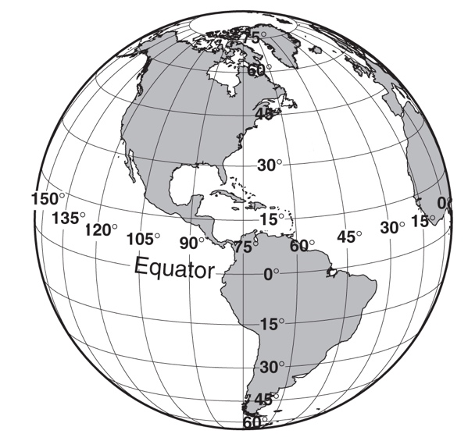
Note: There is difference between “clock time” and “solar time” because of the relatively wide width of what we call a time zone. Meaning, there will always be at least some difference between ________ time and _________ time (because only a very small minority of people live directly on line of longitude at 15 degree intervals (0°, 15° W Long., 30° W Long., …75°W Long, etc.).
Look at the diagram to the right showing a view our earth along the equator:
Draw arrows on the Earth toward the left and right of the line of longitude over NY and label them appropriately “west” and “east”. Keeping in mind that England and all of Europe experience sunrise before we do in North America, the earth must therefore rotate from _______________ to ______________, as we in New York are hidden from the sun while England is experiencing sunrise. This means that if it is high noon – what we now term ___________ noon – for an observer in New York (as is the case to the right), Australia is experiencing ______________ because the sun has not yet risen for an observer in that part of the world.
To summarize, when we travel from _________ to __________, we must subtract time from our watch. In contrast, when we travel from ___________ to east, we must _____________ ____________ to our watch. Again, this is all based on the observation that the apparent ____________________ of the ______________ across the sky is how we base time on earth.

