EARTH SCIENCE REGENTS
TEACHER VERSION – SEE LAST PAGE FOR RESOURCES
Name___________________ Period ____ Lab # ________
Reading Isobars
Copyright 1998 by S. Kluge, Updated by Z. Miller 2019

The accompanying map shows the Gulf of Mexico as Hurricane Michael traveled north heading for the northwestern Florida coastline on October 10, 2018. Hurricane Michael was notable for undergoing two rapid intensification periods (an increase in wind speed of 35 mph (miles per hour) in less than 24 hours) leading to 160 mph winds at landfall. The gray areas are land areas. The small dots surrounded by numbers and letters are station models. The data was collected at land based weather stations, aboard ships and oil rigs, and remotely sent by radio from weather buoys anchored in the Gulf. Radio waves are absorbed by water, so data transmitted from remote stations can be lost in high seas and/or heavy rain. The most reliable information comes from manned, land based stations. The isolines are isobars.

1. Label Florida (FL) in small letters at Lat. +29 Long. -82.
2. Label Cuba (CUBA) at Lat. +22.5 Long. -81.
3. Label the Texas coast (TX) at Lat. +29 Long. -97.
4. Label Louisiana (LA) at Lat. +30.5 Long. -91.
5. Label the Yucatan Peninsula (YUC) at Lat. +19.5 Long. -89

Examine the station models and the isobars on the map.
6. Are the pressures at the station models coded? ______
7. Describe the wind direction in the area between by Lat +22 and Lat. +30 and Long -82 and Long. -92.

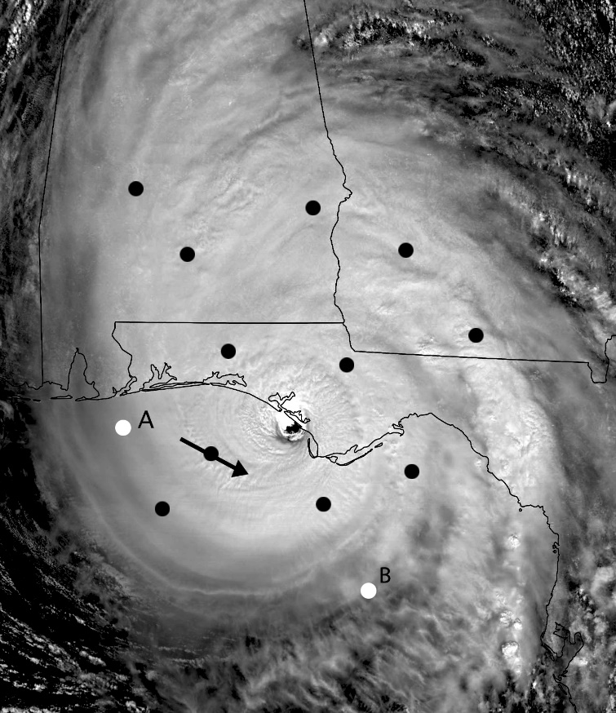
8. Is that description in agreement with what you know about the movement of air around low pressure systems? ___________

8A. The image to the left was made on 10/10/2018 (the same day the map was made) and several points (have been added to the image for this lab. At each of the points, draw a small (1 cm length) arrow to indicate the direction of air flow at that point. One arrow has already been drawn.
Is the air flow pattern you've drawn consistent with your answer to # 7 above? _____ If not, examine the map again and re-write your answer to # 7.
8B. Mark the area of lowest pressure with the letter "L"
8C. Draw possible station models at points "A" and "B"
8D. Write a sentence describing the direction of air flow around a Low pressure system

See the web address below for a visible loop of Michael
https://cimss.ssec.wisc.edu/goes/blog/wp-content/uploads/2018/10/181010_goes16_visible_Hurricane_Michael_anim.mp4

9. Look at your map again. Are the isobars on the map coded? ___________
On the map, locate the isobar labeled “10” (at Lat. +21 Long. -84).
10. What is the decoded pressure along that isobar?___________

Notice the labels on the isobars surrounding the “10” isobar.
11. What is the isobar interval of this map?___________
12. What is the highest wind speed reported on the map?_____________
13. What is the lowest pressure reported on the map? _____________
14. What is the location of the station reporting the highest wind speed and lowest pressure?
(To the nearest 0.1 degree)
Lat. ___________ Long. ____________

15. Determine the pressure gradient expressing your answer to the nearest thousandth (0.001) from the center of the storm (marked with a dot (●) within the eye at Lat. +27.7 Long. -86.6, pressure 945 mb) to a gray dot (●) at Lat. +30 Long. -80 northeast of the storm’s eye.

Rise = __________mb
Gradient = ______________mb/NM
Run = __________NM
16. Determine the pressure gradient expressing your answer to the nearest thousandth (0.001) from the center of the storm (marked with a dot (●) within the eye at Lat. +27.7 Long. -86.6, pressure 945 mb) to a gray dot (●) at Lat. +25.5 Long. -93. Make sure you record units, too!

Rise = __________
Gradient = ______________
Run = __________
Draw a line from the two gray dots (●) at Lat. +25.5 Long. -93 to Lat. +30 Long. -80. Label the appropriate ends of the line “NE” and “SW”.
17. Use the graph paper below to construct a profile of the storm from SW to NE. Label everything and remember that neatness counts!

Carefully and thoughtfully answer/do the following:
18. According to your graph, on which “side” of the storm is the pressure gradient steepest?_________

19. According to your graph, on which “side” of the storm is the pressure gradient smallest?_________

20. How do those observations compare with the gradients you calculated in questions 15 and 16 above?

21. Does there seem to be a relationship between pressure gradient (as indicated by close spacing of isobars) and wind speed?________. On which "side" of the storm is the wind speed the greatest?______________
22. Write a sentence describing how wind speed is related to pressure gradient?

23. Draw the graph below:

Wind Speed

Pressure Gradient
CHALLENGE:
Go to the following website showing a cloud intensity loop for Hurricane Michael:
https://cimss.ssec.wisc.edu/goes/blog/wp-content/uploads/2018/10/181010_goes16_infrared_zoom_Hurricane_Michael_anim.mp4
Answer the following questions:
1. As hurricanes come on shore, on which side of the storm (east or west) is damage from wind and storm surge going to be the greatest?_______ EXPLAIN:

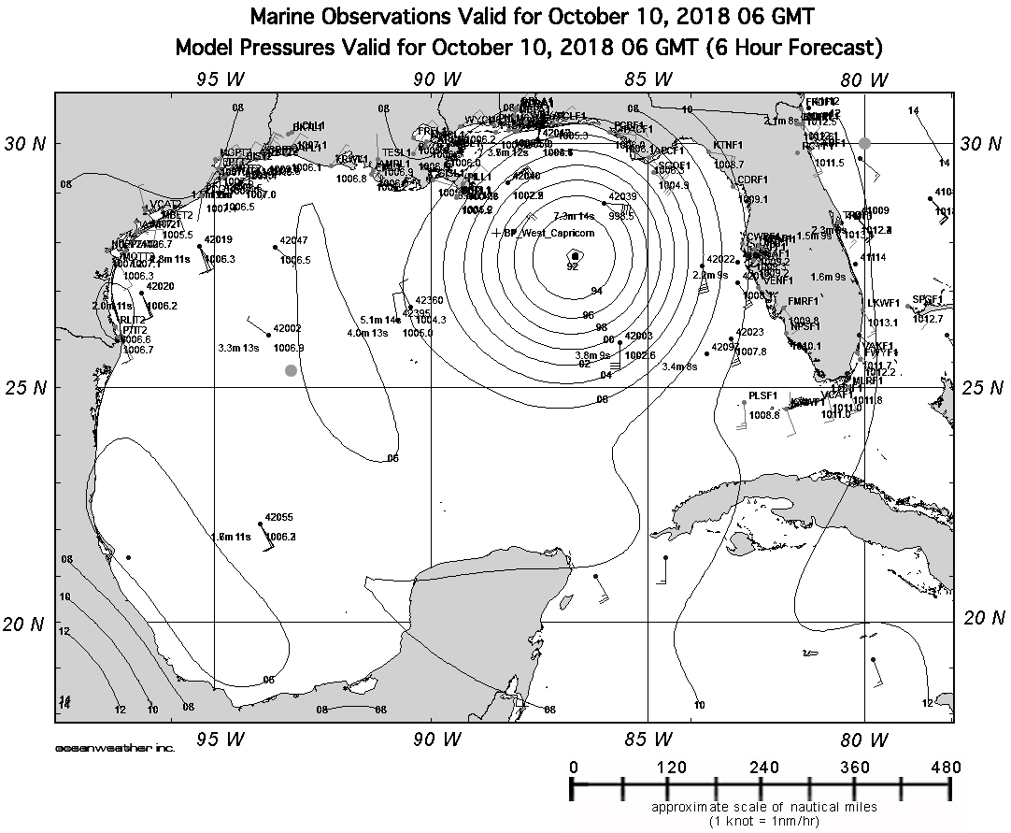

TEACHER RESOURCES

The items below are supplements to the above Hurricane Michael lab activity. These resources include satellite images & loops (animations), articles, tutorials on cyclone and hurricane development, and a variety of resources that can accompany this lab activity.

**Animation/Loop included in the lab above.

University of Wisconsin-Madison
Hurricane Michael Visible Satellite Loop – October 9, 2018
https://cimss.ssec.wisc.edu/satellite-blog/wp-content/uploads/2018/10/181009_goes16_visible_Michael_anim.mp4

Hurricane Michael Infrared (approaching landfall) Satellite Loop – October 10, 2018
https://cimss.ssec.wisc.edu/satellite-blog/wp-content/uploads/2018/10/181010_goes16_infrared_Hurricane_Michael_anim.mp4

**Hurricane Michael Visible (approaching landfall) Satellite Loop – October 10, 2018
https://cimss.ssec.wisc.edu/goes/blog/wp-content/uploads/2018/10/181010_goes16_visible_Hurricane_Michael_anim.mp4

**Hurricane Michael Infrared (at Landfall) Zoom Satellite Loop – October 10, 2018
https://cimss.ssec.wisc.edu/goes/blog/wp-content/uploads/2018/10/181010_goes16_infrared_zoom_Hurricane_Michael_anim.mp4

Top Directory (folder) of resources from University of Wisconsin-Madison (where above animations were found):
https://cimss.ssec.wisc.edu/satellite-blog/wp-content/uploads/2018/10/

Weather Underground
Hurricane Michael Upgraded to Category 5 at Landfall:
https://www.wunderground.com/cat6/Hurricane-Michael-Upgraded-Category-5-Landfall

New York Times
Among the Ruins of Mexico Beach Stands One House, Built ‘for the Big One’
https://www.nytimes.com/2018/10/14/us/hurricane-michael-florida-mexico-beach-house.html

NASA – How Do Hurricanes Form?
https://pmm.nasa.gov/education/articles/how-do-hurricanes-form

NASA Earth Observatory
Florida Slammed by Hurricane Michael
https://earthobservatory.nasa.gov/images/92868/florida-slammed-by-hurricane-michael

Inside Hurricane Michael as it made landfall (ABC video footage)
https://www.youtube.com/watch?v=gpyT7FR4Ums&t

Extreme 4K Video of Category 5 Hurricane Michael (storm chaser footage)
https://www.youtube.com/watch?v=wSXvcveNSTQ

NATIONAL HURRICANE CENTER and CENTRAL PACIFIC HURRICANE CENTER
https://www.nhc.noaa.gov

